Dockerfile
- Docker can build images by reading instructions from a Dockerfile
- Let’s take one more application as an example
  - This application is based on java
  - This application runs on port 8080
- Let’s try to install this java application on a linux machine first
- create a ubuntu linux vm on any cloud. login into linux machine using ssh
  - install java
  - download spring pet clinic application
sudo apt update
sudo apt install openjdk-8-jdk -y
java -version
wget https://referenceappkhaja.s3-us-west-2.amazonaws.com/spring-petclinic-2.2.0.BUILD-SNAPSHOT.jar
java -jar spring-petclinic-2.2.0.BUILD-SNAPSHOT.jar
Now navigate to http://publicip:8080 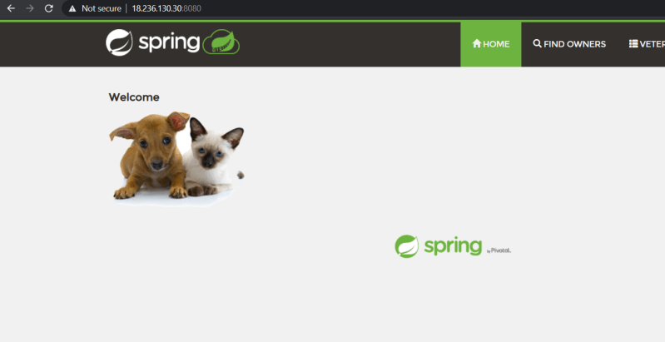
- To create a docker
  - We have to choose a right base image
    - You can choose ubuntu and perform all the steps
    - Choose a image where java is already installed
- To build Dockerfile we will be using instructions (Link: https://docs.docker.com/engine/reference/builder/)
- So lets build a Dockerfile using ubuntu:18.04 image
  - To set the base image we will be using FROM instruction ( Link: https://docs.docker.com/engine/reference/builder/#from)
  - Now we need to divide our commands which we use to install/configure our application into two sections
    - application installation/configuration steps. All the configuration steps we will be using can be written in Dockerfile with RUN instruction (Link: https://docs.docker.com/engine/reference/builder/#run)
  - apt update
  - apt install openjdk-8-jdk wget -y
  - wget https://referenceappkhaja.s3-us-west-2.amazonaws.com/spring-petclinic-2.2.0.BUILD-SNAPSHOT.jar
    - application execution steps. Execution steps will be configured with instruction CMD
  - java -jar spring-petclinic-2.2.0.BUILD-SNAPSHOT.jar
    - Our application when executed might require some port to connect, in this case the port is 8080, we use EXPOSE instruction to specify ports of application
- Create a folder and then place the Dockerfile in it. Now build the docker image using docker image build command.
docker image build -t spc:ubuntu .
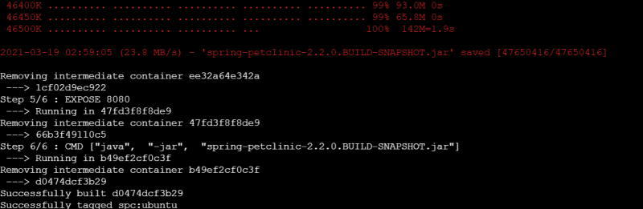
Now lets check the docker images in the local machine (local repository) docker image ls 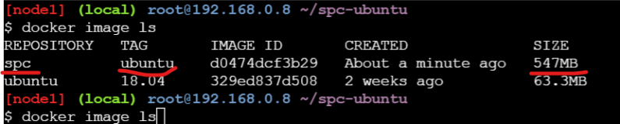
- Building a Image using openjdk image
- To copy the jar file into container use the ADD instruction
- Lets try to build the docker image
docker image build -t spc:openjdk .
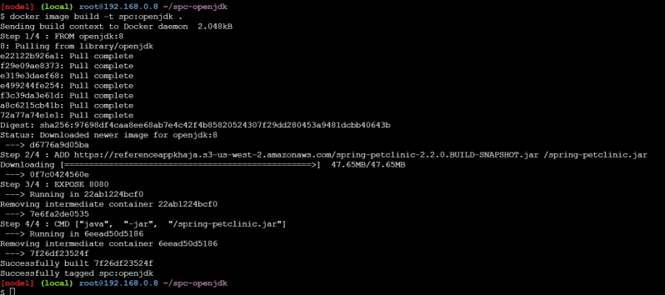
- Lets view the docker image in the local registry 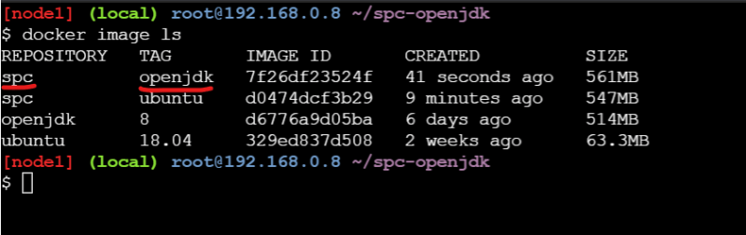
- Now lets try to run the application in a docker container using two images which we have built 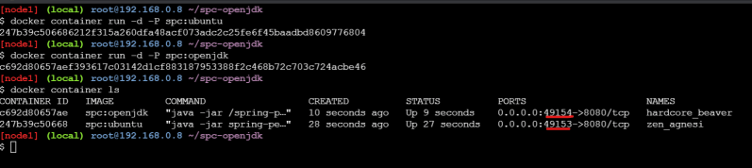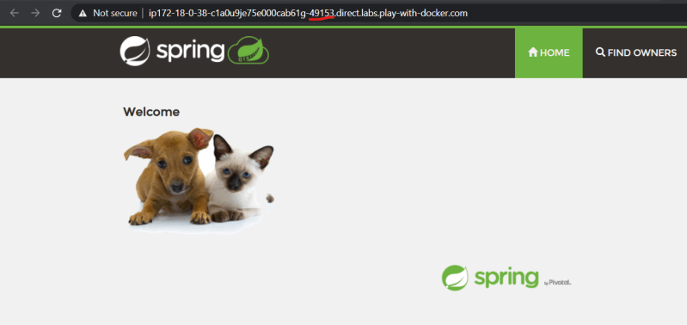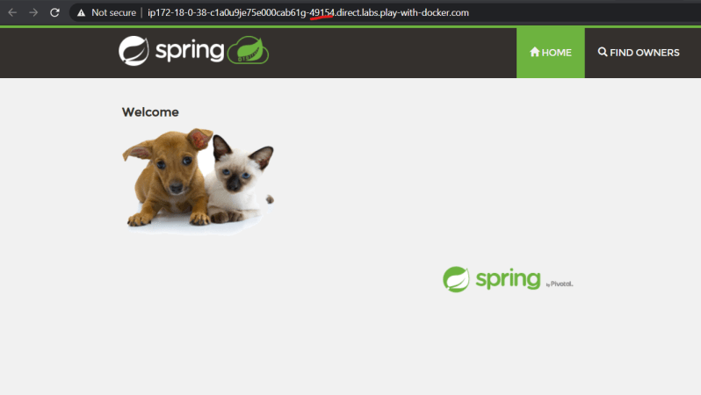
- To build a docker image for an app we will have multiple approaches, try to use the approach which is simpler and which results in consuming less resources
- Dockerfiles used in the class room
FROM ubuntu:18.04 RUN apt update RUN apt install openjdk-8-jdk wget -y RUN wget https://referenceappkhaja.s3-us-west-2.amazonaws.com/spring-petclinic-2.2.0.BUILD-SNAPSHOT.jar EXPOSE 8080 CMD ["java", "-jar", "spring-petclinic-2.2.0.BUILD-SNAPSHOT.jar"]

Slim version of spc
FROM openjdk:8 ADD https://referenceappkhaja.s3-us-west-2.amazonaws.com/spring-petclinic-2.2.0.BUILD-SNAPSHOT.jar /spring-petclinic.jar EXPOSE 8080 CMD ["java", "-jar", "/spring-petclinic.jar"]

